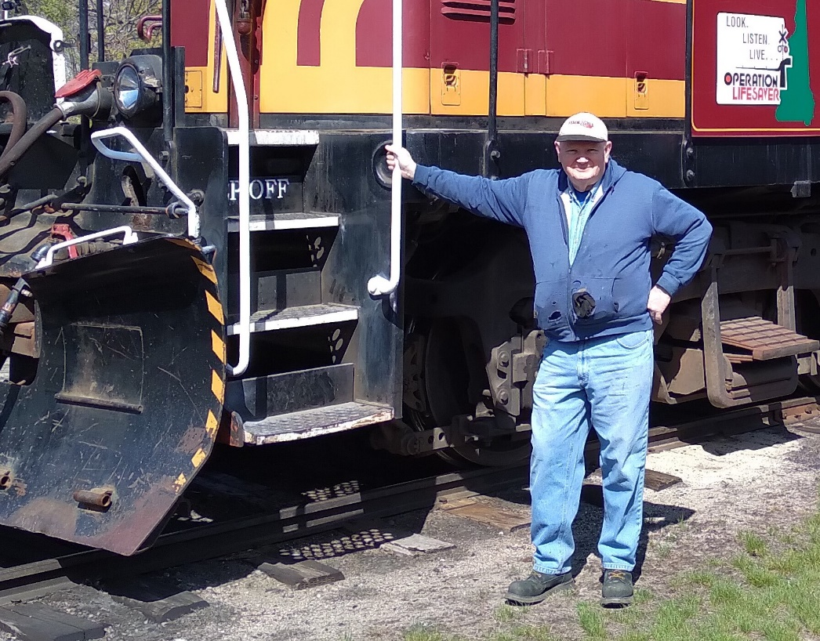

I’ve been modeling trains since I was a 4-year-old on and off. I’m a retired Air Force guy with 23 years of service and worked for the Air Force after that for addition 20 years. My wife (Marianne) and I were assigned back home in Massachusetts in 1983 to Hanscom AFB in Bedford, MA. We’ve lived in Waltham, MA now 41 ½ years now.
During an anniversary trip to northern New Hampshire in 1984, I fell in love with the Conway Scenic Railroad. On a return trip to visit the CSRR’s expansion thru to Crawford Notch in 1995, I was given every kids dream, a chance to work on a railroad. I was their signal maintainer for several years, done numerous projects all over the railroad and maintainer qualification as a conductor since 2009 until last year. I also own and stay in an antique Maine Central railroad car that I convert the inside of to live in there on the property.
I’ve involved with work on several project at the ARC club from the early days of the HO layout in the basement, to the installation of both of the outside sheds with electrical power, water line throughout the back yard area. I’ve spent countless weekends involved to the development of the live steam raised running track and I continue spending extensive weekend’s developing the grounds, landscaping and track work for Garden Railway. I’ve also been active with the Beltlines at shows since even before becoming a paid ARS club member in 2016; and have been hanging around many of the Belt Lines guys since well before that. I’ve repaired several pieces of donated model train equipment for Ken so they could be sold as working items.
I’ve been wrestling with what I could do more along the lines of club operation for over a year now and would like to put my name up for a post on the board.

